Intiating the docker and its container

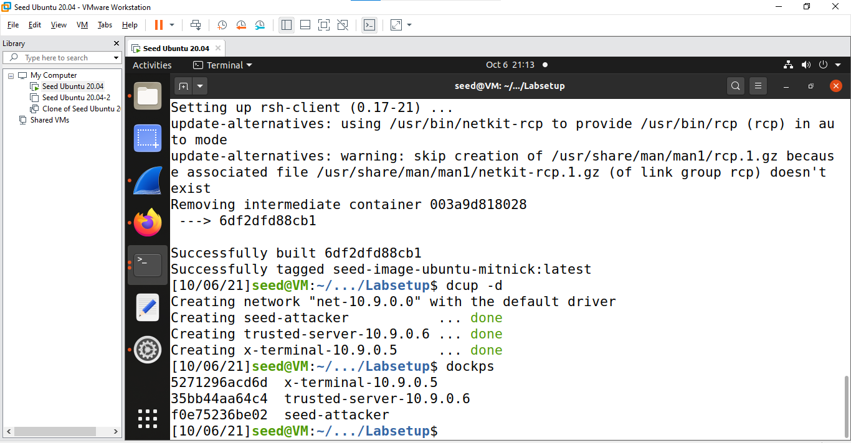

Checking the trusted server ip address and mac address

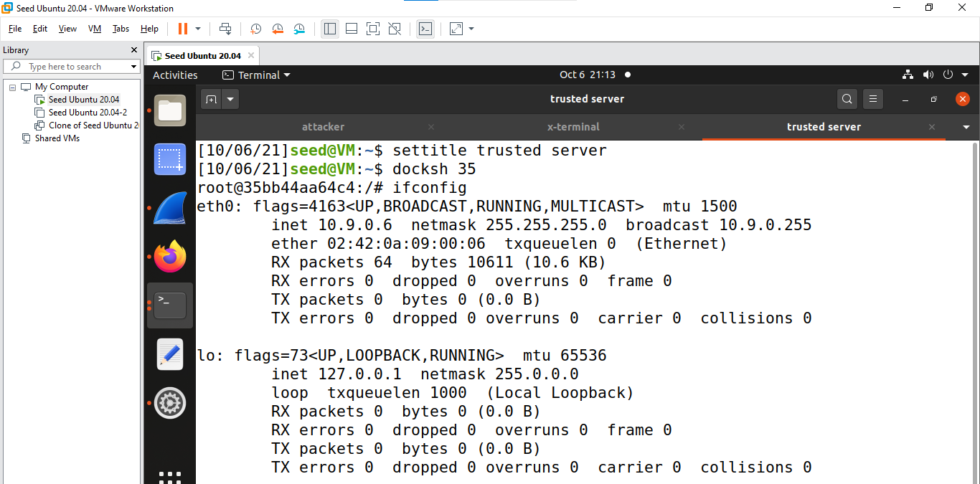

# TASK -1

Ping the server ip address from X-Terminal

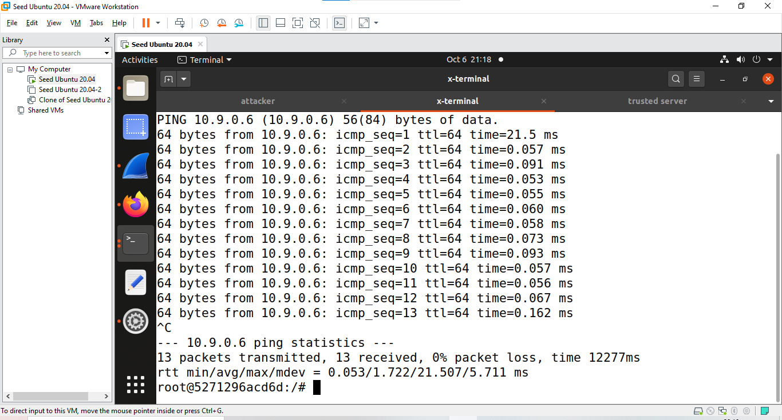

Running arp –n command

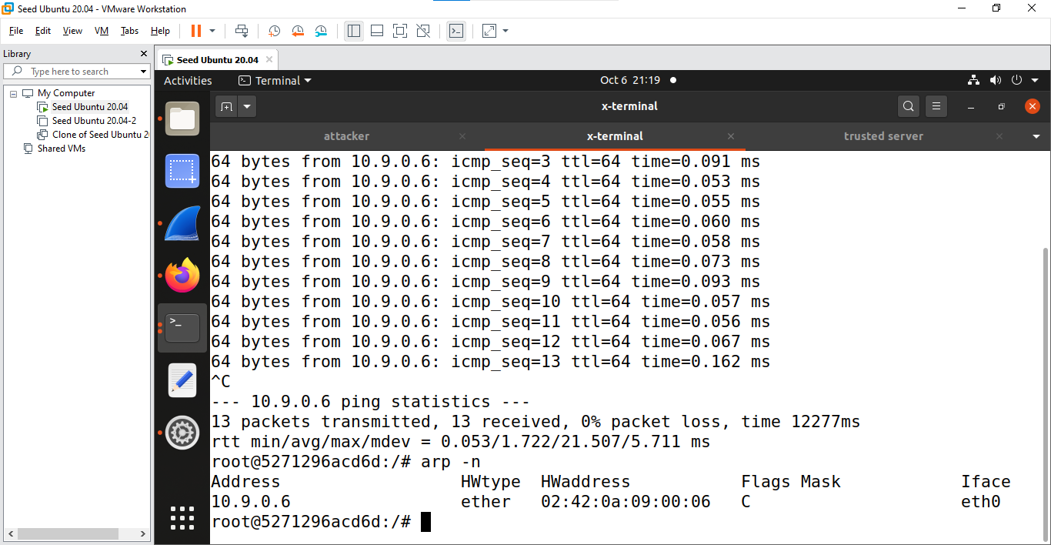

Disconnecting the trusted server 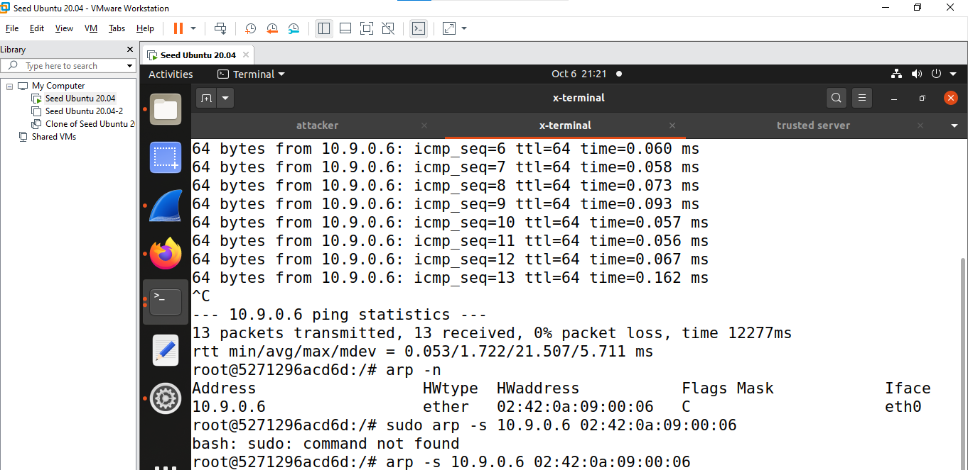

# Task 2: Spoof TCP Connections and rsh Sessions